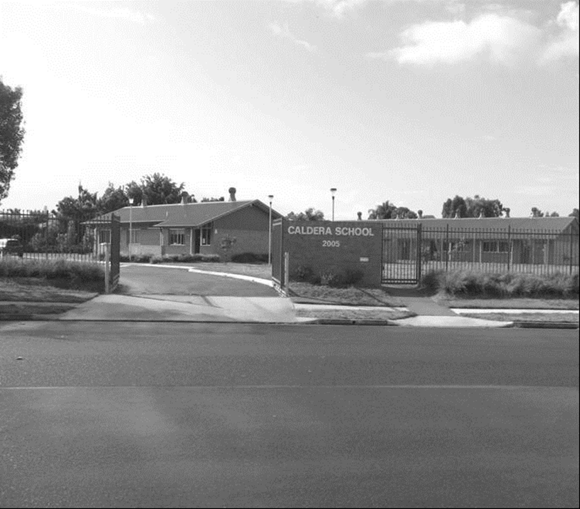

**5573**

Caldera School

**Annual School Report 2014**

**[school code]**

School context statement

Caldera School is a Specific Purpose School designed for students from Year 7 – Year 12 who display significant challenging behaviour. It is an alternative Department of Education and Communities facility created to meet the needs of students whose behaviour has prevented them from being maintained in a regular school setting.

The school was established in 2002 and provides programs which aim to support students’ transition into the wider community. The school is located at 37 Corporation Circuit, Tweed Heads South.

Student information

In 2014 total enrolment in the Caldera Secondary program at Tweed Heads South was twenty eight

The school also provides education and transition support to the Child and Adolescent Mental Health Inpatient Unit (CAMHU) located at Lismore Base Hospital where there is a capacity for eight students.

Student enrolment profile

Enrolment figures taken from mid-year census.

Year 12 students undertaking vocational or trade training

2014 marked the first year that a student graduated from Caldera School with a school-based apprenticeship after completing his HSC with a certificate in Meat Processing (retail butchery).

Year 12 students attaining HSC or equivalent Vocational educational qualification

Two students attained their HSC in 2014 with one of them completing a vocational education qualification certificate in Meat processing.

Workforce information

It is a requirement that the reporting of information for all staff must be consistent with privacy and personal information policies.

Workforce composition

|  |  |
| --- | --- |
| Position | Number |
| Principal | 1 |
| Deputy Principal(s) |  |
| Assistant Principal(s) | 2 |
| Head Teachers |  |
| Classroom Teacher(s) | 5.072 |
| Teacher of Reading Recovery |  |
| Learning and Support Teacher(s) |  |
| Teacher Librarian |  |
| Teacher of ESL |  |
| School Counsellor | .3 |
| School Administrative & Support Staff | 7.822 |
| Total | 16.194 |

The Australian Education Regulation, 2014 requires schools to report on Aboriginal composition of their workforce.

No Aboriginal staff at Caldera SSP.

Teacher qualifications

All teaching staff meet the professional requirements for teaching in NSW public schools.

|  |  |
| --- | --- |
| Qualifications | % of staff |
| Degree or Diploma | 70% |
| Postgraduate | 30% |

Professional learning and teacher accreditation

Staff Development:

Activities undertaken in 2014

* Code of conduct
* Child protection
* Life skills HSC
* Fitness program
* Stephanie Alexander Garden program
* White Ribbon Program
* Nationally consistent collection of data (NCCD)
* new transition plans
* assessment
* art ideas
* iPads, creating digital units of work,
* The staff also worked together on our philosophy of working with Challenging students and including behaviour management, review of the school’s philosophy, plan B revision, unsolved problems, lagging skills and language ideas

Financial summary

This summary covers funds for operating costs and does not involve expenditure areas such as permanent salaries, building and major maintenance.

|  |  |
| --- | --- |
| Date of financial summary | 30/11/2014 |
| ***Income*** | $ |
| Balance brought forward | 377407.09 |
| Global funds | 120609.93 |
| Tied funds | 35943.14 |
| School & community sources | 26.40 |
| Interest | 10329.48 |
| Trust receipts | 0.00 |
| Canteen | 0.00 |
| Total income | 544316.04 |
| ***Expenditure*** |  |
| Teaching & learning |  |
| Key learning areas | 16073.58 |
| Excursions | 0.00 |
| Extracurricular dissections | 9159.86 |
| Library | 120.24 |
| Training & development | 1625.82 |
| Tied funds | 47650.25 |
| Casual relief teachers | 1870.93 |
| Administration & office | 35690.49 |
| School-operated canteen | 0.00 |
| Utilities | 15268.82 |
| Maintenance | 6202.10 |
| Trust accounts | 0.00 |
| Capital programs | 0.00 |
| Total expenditure | 133662.09 |
| **Balance carried forward** | 410653.95 |
|  |  |

A full copy of the school’s 2014 financial statement is tabled at the annual general meetings of the School Council and/or the parent body. Further details concerning the statement can be obtained by contacting the school.

Academic achievements

NAPLAN

In the National Assessment Program, the results across the Years 3, 5, 7 and 9 literacy and numeracy assessments are reported on a scale from Band 1 to Band 10.

The achievement scale represents increasing levels of skills and understandings demonstrated in these assessments.

**Year 9**

|  |  |  |  |  |  |
| --- | --- | --- | --- | --- | --- |
| Subject | Band 5 & 6 | Band 7 | Band 8 | Band 9 | Band 10 |
| Reading | 2 |  |  |  |  |
| Writing | 2 |  |  |  |  |
| Language | 2 |  |  |  |  |
| Numeracy | 1 | 1 |  |  |  |

Click on the link <http://www.myschool.edu.au>

and enter the school name in the *Find a school* and select *GO* to access the school data.

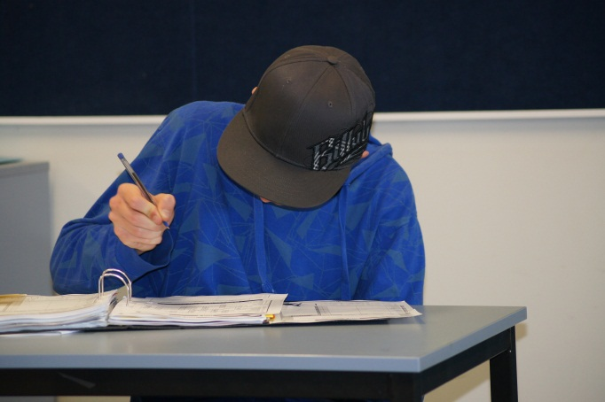

Record of School Achievement (RoSA)

In 2014 five students completed the ROSA either through support of programs offered by Southern Cross Distance Education Centre and/or Life Skills based program at Caldera. The school has now supported sixty six students to achieve either a School Certificate or RoSA.

Higher School Certificate (HSC)

In 2014 two students were able to complete their HSC through a combination of programs offered by Southern Cross Distance Education Centre, TAFE and Life Skills. One student graduated whilst completing a school based apprenticeship.

Significant programs and initiatives – Policy and equity funding

Aboriginal education

Six students with Aboriginality enrolled at Caldera in 2014. Each of these students has Individual Plans to support their academic, behaviour and transition needs. These plans were negotiated with students and their families.

Multicultural education

The staff and student population at Caldera is comprised of people with diverse cultural backgrounds. Opportunities exist for students and staff to exchange experiences and knowledge about a range of cultures, thus preparing students for a culturally diverse society. The school has an Anti-Racism Contact Officer.

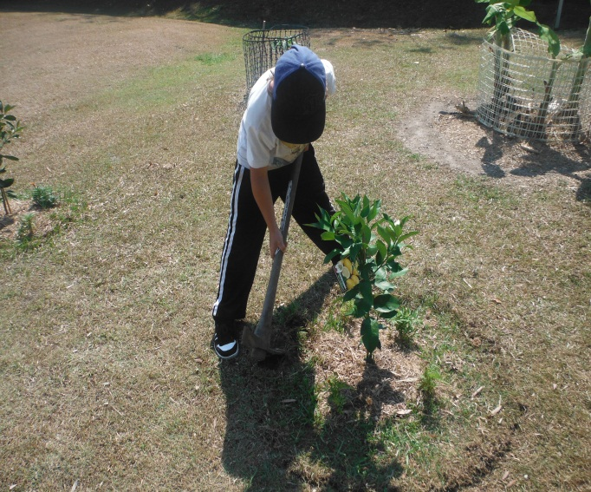

Healthy eating program

The school continued its healthy eating program in 2014 – devoting further resources to continue this program after Commonwealth Government funding finished in 2006.

The program allowed students to improve their living skills in preparing, cooking and serving a range of healthy meals as part of their individualised programs. The school was awarded, in 2012, a Stephanie Alexander Kitchen Garden grant. The school has developed a new kitchen and preparation area as well as 10 garden beds.

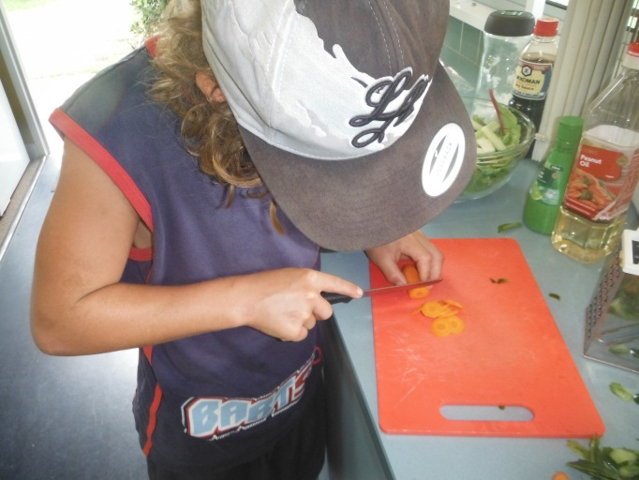

White Ribbon:

2014 marked the inaugural year of Caldera school’s involvement in the White Ribbon initiative. After undergoing professional development, a teacher implemented a school wide program raising awareness on domestic violence and abuse. It culminated in a White Ribbon day at the school where students displayed their work. A BBQ lunch was provided and a guest speaker addressed the students.

School planning and evaluation 2012—2014

School evaluation processes

NSW public schools conduct evaluations to support the effective implementation of the school plan. The processes used include:

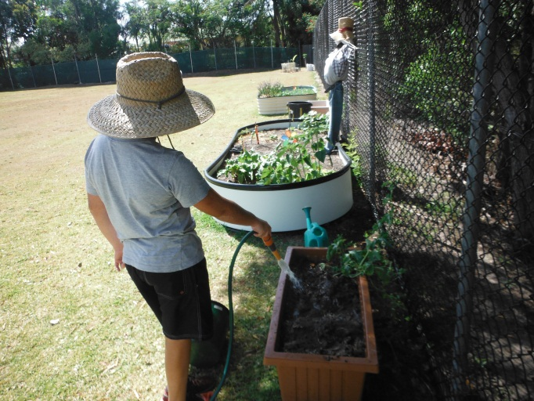

School planning 2012-2014:

School priority 1

Technology:

Use of technology to assist in meeting student needs.

Outcomes from 2012–2014

Teachers increased incorporation of multimodal forms of content delivery and assessment in order to increase student engagement and cater to an individual’s learning style.

New electronic transition plan and report formats.

Evidence of achievement of outcomes in 2014:

* Increased use of multimodal lessons in student individual education plans.
* Increased teacher proficiency in planning and reporting.

Strategies to achieve these outcomes in 2014

* Teacher development in digital learning. Creating digital units of work that align with the outcomes of the national curriculum.
* Implement Google apps for education in order to enhance the digital learning experience.

School priority 2

Curriculum and assessment

Outcomes from 2012–2014

* Teachers underwent training in delivering the stage 5 Australian and regular mainstream curriculums by adjusting the syllabus and assessment tools that are catered to the individuals learning capacity.
* A new report format was created that was more functional in reporting on student outcomes partaking in the Australian curriculum.
* Stage 6 students were enrolled in achievable patterns of study that would allow them to attain their HSC.

Evidence of progress towards outcomes in 2014:

* There was an increase in the number of stage 5 students who were enrolled in Australian curriculum and mainstream subjects. Teachers successfully transitioned into reporting in the new report format.
* Two students attained their HSC. A further two students enrolled in the preliminary course in an achievable pattern of study.

**Strategies to achieve these outcomes in 2014:**

* Further refine and develop engaging and achievable units of work and assessment tools that align with the Australian Curriculum as well as incorporating elements of digital learning.
* Transition the students in Year 8 and 10 into Australian curriculum for English, Mathematics, History and Science.

Parent/caregiver, student, and teacher satisfaction

In 2014, the school sought the opinions of parents, students and teachers about the school.

The thoughts and opinions of families, students and staff regarding the school and how it operates were sought through various ways including;

* Interviews
* Surveys
* Transition Meetings
* Daily Debriefings

Future Directions

2015-2017 School Plan

NSW DEC is implementing a new school planning process for 2015-17. The new plan will be published on the school’s website from the beginning of Term 2 2015.

The areas of focus for Caldera are:

* Wellbeing framework.
* Teacher quality and accreditation.
* Technology in the classroom to assist student engagement and performances.

About this report

In preparing this report, the self-evaluation committee has gathered information from evaluations conducted during the year and analysed other information about the school's practices and student learning outcomes. The self-evaluation committee and school planning committee have determined targets for the school's future development.

Keith Marshall, Principal

Michael Hoolihan, Assistant Principal

Tai Shimizu, Assistant Principal/Teacher

School contact information

Caldera SSP

37 Corporation Circuit, Tweed Heads South, NSW 2486

Phone: 0755 243 244

Fax: 0755 249 536

Email: caldera-s.school@det.nsw.edu.au

School Code: 5573

Parents can find more information about Annual School Reports, how to interpret information in the report and have the opportunity to provide feedback about the report at:

<http://www.schools.nsw.edu.au/learning/emsad/asr/index.php>

